Access syllabus/presentations

Instructions to access and manage your activity syllabi.

Via computer
Step 1: Go to: https://jefferson-lehigh.cloud-cme.com

Step 2: Click Sign In, and sign in using your email address and password.
Step 3: Click the My CME or My CE button.
Step 4: Click Syllabus.

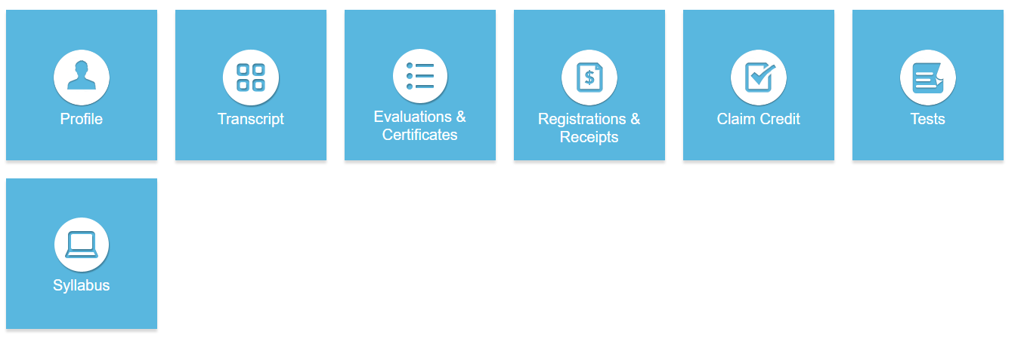

Step 5: Click the Syllabus button next to the activity to view the syllabus.

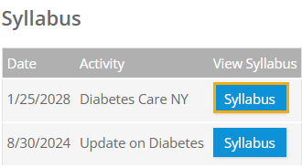

Step 6: You will see the activity syllabus details. Click on the presentation icon to view the presentation.

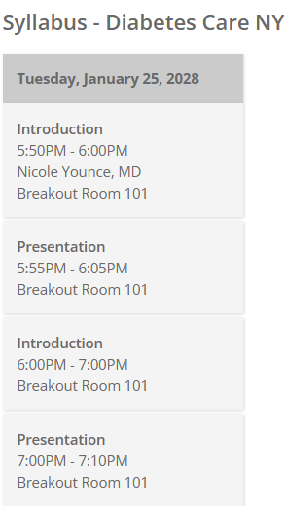
Via CloudCME App
Step 1: Open the CloudCME App.

Step 2: Login using your email address and password.
Step 3: Select Syllabus on the menu.

